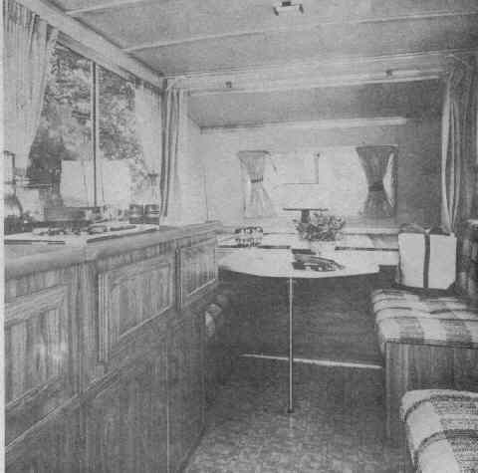
1980
APACHE

SOLID STATE
CAMPING TRAILER
OWNER’S MANUAL

TO THE NEW APACHE OWNER:
Your new Apache has the most advanced engineering of any folding camping trader. Many of its features are designed for extra living comfort, easy towing, and fast set-up at the campsite.

This owners manual has been prepared to acquaint you with these features and to explain the proper operation and maintenance of your Apache. Read the entire manual carefully before you set up the trailer for the first time. It’s a good idea to keep the manual inside the trailer so it will be available for reference.

To be sure your Apache gets the expert care it deserves, see your Apache Dealer. He has the special tools, genuine parts and technical know-how to keep it in top condition. He also handles a complete line of Apache comfort and convenience accessories. Apache Dealers are located throughout the U.S. and Eastern Canada. When traveling, find the dealer nearest you by consulting the Yellow Pages under “Recreational Vehicles” or “Trailers-Camping and Travel”.

All instructions and specifications in this manual were considered correct at the time of publication. Vesely Company reserves the right to make changes at any time, without notice or obligations, in specifications, designs, equipment and materials.

INDEX Page
Getting Acquainted 1
Getting Ready to Go 1
Set-Up Instructions 3
Striking 7
Operation 8
Water System 14
Electrical Systems 16
Gas System 20
How to Keep Your Apache Looking New 22
Maintenance 24
Storage 26
Specifications 27

Vesely Company
2101 North Lapeer Road,
Lapeer, Michigan 48446
GETTING ACQUAINTED

Set-up your new Apache and run through the following list to familiarize yourself with its features. Before taking an extended trip, its always a good practice to take a short “shake down’ trip first.

1. Read the entire manual.

- Set up the trailer in accordance with the set up instructions.

3. Check operation of all accessories.

4. If equipped with a furnace, operate for a couple of hours to burn off new smell.

5. Check to see that your cars lug wrench fits the trailer lug bolts.

GETTING READY TO GO

THINGS TO TAKE ALONG

1. Extra fuses and bulbs (see specifications for type).

2. Hydraulic or scissors jack.

3. Lug wrench (if cars lug wrench does not fit).

4. Stabilizer jack handle.

5. Crank.

6. Tool kit with pliers, open end wrenches, regular slotted and Phillips head screwdrivers.

7. 50 foot garden hose. (For city water hook up).

- 15 foot garden hose. (For waste water disposal at sites with sewer hook up).

- Pail. (For waste water disposal at sites without sewer hook up}.

10. Five blocks of wood (6” x 6” x 1” approximately).

11. Tire air pressure gauge. (In increments exceeding 50 PSI).

12. First aid kit.

13. Fire extinguisher.

NOTE: items 4, 5, and 13. are supplied with the trailer.

LOADING YOUR CAMPER

The maximum carrying capacity of your trailer is given in the specifications section of this manual. From this capacity, you must subtract the weight of accessories, water, LP gas, and camping gear. Exceeding this capacity may result in premature tire life, and frame and/or axle damage.

Camping gear should be stowed so as to prevent excessive movement- Also, it should be distributed so that 10% to 12% of the GVW (total weight) rests on the coupler ball for the best towing results. This can easily be checked using a bathroom scale, as shown below.

- With trailer fully loaded, position as shown and level with tongue jack.

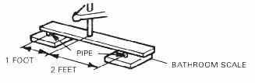
- Multiply scale reading by 3. Also ensure even weight distribution between right and left hand sides of trailer. Uneven balance can greatly affect towing stability.

Never carry any object on the road cover of your trailer. Not only could it damage the cover, it will affect the towing performance and may add to over-loading.

PHYSICAL CHECK OF TRAILER

- Tires inflated to correct pressure. (Stamped on sidewall of tire)

2. Lug bolts tightened to 110 ft-lbs.

3. Coupler is securely fastened and locked.

4. Safety chain is attached.

5. Electrical harness is connected and all lights operate properly.

6. Gas bottles are properly filled and main valves shut off.

DRIVING

1. Remember you have another vehicle behind you when

a. passing
- stopping, try to anticipate stops
- turning

- Check side view mirrors often to eliminate surprise over-takings.

- When backing, the trailer will go in the opposite direction of which you turn the front wheels of the car.

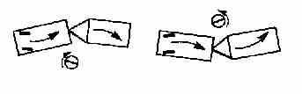
SET UP INSTRUCTIONS

1. Pull trailer onto campsite. Try to position trailer so that majority of leveling is to be done from front to rear- If the trailer must be set on a slope, block the wheels with large rocks or carry a couple pieces of wood (at least 4x4)

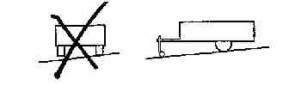
2. Detach safety chains. electrical hook-up, and slip tongue jack wheel over jack sleeve (locking pin on wheel fits into slot in sleeve). Place block of wood (1x 6 x 6) under wheel if ground is soft

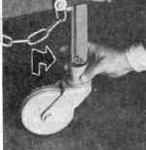
3. Unlock coupler from hitch ball by pulling up on locking bracket. Turn tongue jack handle clockwise to raise trailer tongue until coupler is detached from hitch ball Move car ahead and level trailer, front to back, with tongue jack handle

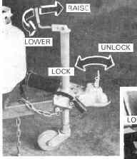
4. Release lock on gear box at rear of trailer. Insert crank and turn clockwise until road cover is at full height position. Do not over crank.

5. Release all four leveling legs, by pushing toward middle of trailer and swinging down to lock position. Extend each leveling leg to ground by placing foot or, base plate and pushing down firmly. When ground is extremely soft, it helps to have four pieces of wood (approximately 6” x 6” x 1”) to position under each leveling leg to prevent sinking.
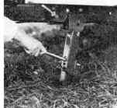
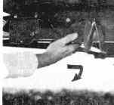
6. through the upper most hole in leveling leg. Depress handle to raise trailer corner upward; follow this procedure at other corners as necessary, until trailer is level front to rear and side to side. and until enough weight has been transferred to the legs for stability. The axle and suspension should still be supporting the weight. In no case should tires be lifted off the ground.

7. Finish raising the two main sidewalls to vertical position and secure in place by pivoting lock latches on sidewalls into the telescope posts.

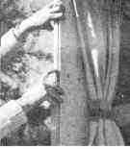
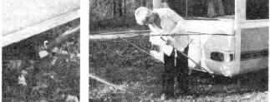
8. Pull up bed leg retainer lock and swing out bed support tubes. Remove the bed legs from their storage postion, on the back of the bed. Place the open end of the bed legs over the stud mounted on the frame. Insert the flattened end into the notch in the bed support tubes. After positioning the bed legs, pull out the beds.

9. On models with door step, position door step by lifting up and pulling out. Open door and lock upper and lower doors together with latch on inside.

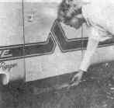
10. Swing galley support leg up to horizontal position. Then swing galley cabinet up into place. Check that
water and gas hoses are not kinked.

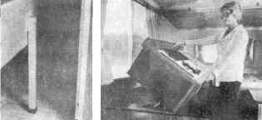
11. Connect the sidewall spring latches to the sides of the road cover. The sidewalls will then be held in the proper place until the road cover is lowered.

NOTE: At times the road cover may be too high for the latches to reach the road cover. If this is the case, connect the latches just before final lowering of the road cover.

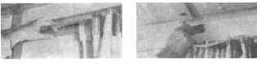
12. Connect sidewall harness to road cover connector.

13. Raise up the bed roof and rear wall until you can reach the opposite end of the bed roof (the end with the dial latches). Grasp the dial latch end of the roof and pull it toward you and unlock dial latches. On the larger beds, it may be more convenient to raise the roof and rear wall to an “A” frame position from the outside. Then continue raising roof to road cover on the inside.

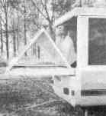
NOTE: It will be easier if you will stack the dinette table and the cushions out of the way to give you a clear area at both ends of the trailer.

14. Lift bed roof up to road cover. Position roof so that locating tabs on dial latch brackets are between the vinyl road cover seal and the aluminum inner trim. Connect both latches to the slots in road cover and turn latch handles until bed roof is secure. Secure latches by folding the handles flat.

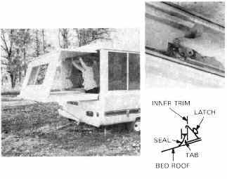
15. Raise bed side panels to approximately a 45 degree angle and pull back from bed.
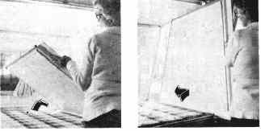

16.. Now finish raising to vertical position and slide into channels in bed end and roof assembly.

NOTE: Repeat steps 13 through 16 to set up other bed end.

17. Crank road cover down slightly until it rests on top edges of sidewalls.

NOTE: Check latches positioned in step 12. Proper center fit of sidewall to road cover is governed by this latch.

18. Install telescope covers on telescope posts at each outside corner of trailer and secure with turn buttons.
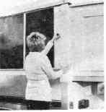

STRIKING

1. Remove telescope covers and crank road cover up. Remove privacy curtains and store.

2. Close and lock all windows. Slide bed side panels back, tilt in, and slide to storage position on bed.

3. Unlock latches securing bed roof to road cover. The latches should be secured to their bases for storage. Fold roof and end wall onto bed.

4. Check that all appliances are turned off. Turn furnace thermostat to OFF. Disconnect sidewall harness. Place tables in travel position.

5. After making sure water in sink and drain hose has drained, swing cabinet down. Lock leg in place.

6. Turn OFF gas bottles.

7. Push door step into travel position.

8. Disengage sidewall latch and tilt walls in.

9. Make sure door is closed and push beds in. Remove bed legs and secure in plastic retainers on back of bed. Swing bed support tubes under end of bed and flip lock down.

10. Release weight from leveling leg by placing foot on tension arm and stepping down firmly. To store leg for traveling, after tension has been released, push tension arm down with one hand and raise base plate with other hand. Swing leg up, make sure it locks in.
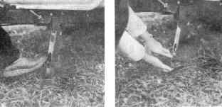

11. Crank down road cover. When the top is down, remove crank and engage rear gear box latch over one of the 3 pins. If the latch does not line up with a pin, turn the latch counter-clockwise to the next pin and latch.

12. Crank coupler up with tongue jack and back car hitch into position.

13. Lower coupler onto hitch ball with tongue jack. Visually check to be sure coupler is latched to trailer ball. Raise tongue jack high enough to remove caster wheel. Then, raise tongue jack to highest position.

NOTE: Cranking the tongue jack until it stops will lock caster wheel and will not allow its removal,

14. Connect electrical hook-up and safety chains. Chains should be criss-crossed under coupler.

15. Check that all hatches and exterior doors are closed and latched.

16. Check tires for pressure and lug bolts for tightness.

17. Are the gas bottles turned OFF?

OPERATION

Before attempting to operate any appliances, thoroughly read the gas and electrical system sections of this manual.

DINETTE TABLES

To set up the table grasp the front edge and slightly pull the table toward you and at the same time lift upwards on the table. The table will now be disengaged from the support bracket. Raise up the table so that the back is on the upper support bracket and the front is about one foot higher. Reach under the table and swing down the table leg until it snaps in a locked position, then lower the front edge of the table.

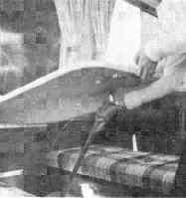
GAUCHO SEAT (RAMADA & CIMARRON)

In order to make the seat into a bed; lift the front edge of the seat cushion and pull the seat part way out. Fold down support legs on front of seat and then finish pulling out seat until it engages the stops. Position back cushion between seat and trailer sidewall to complete bed.

FURNACE

The furnace, currently factory installed, is of the electronic ignition type. Therefore, it does not have a pilot light.

LIGHTING INSTRUCTIONS

1. To light the furnace, turn the manual valve to the “OFF” position and wait 5 minutes with blower running. (Set thermostat above actual temperature to operate blower.)

2. After 5 minutes, set the thermostat to the “OFF” position.

3. Open manual valve. (Correct operating characteristics depend on this valve being positioned fully open. Never attempt to operate with valve partially closed.)

4. Set thermostat on desired temperature.

5. Allow 15 seconds for main burner to light.

6. If burner does not light, set thermostat to “OFF” and repeat steps I through 5.

7. If after 3 tries and no ignition, go to shut down and determine cause.

TO SHUT DOWN

1. Turn manual valve to the “OFF” position.

2. Set thermostat to OFF.

CAUTION: Gas supply and thermostat must be “OFF” when closing trailer.

SEQUENCE OF NORMAL OPERATION

1. When the thermostat calls for heat, the blower motor is energized immediately.

2. As the blower motor reaches approximately 75 percent of the normal r.i.p. (within 3 to 5 seconds) the microswitch in response to the air flow, will engage allowing current flow to the solenoid valve and the spark ignition system.

3. The current to the valve opens it and allows gas to the main burner. The spark then ignites the main burner. Once the flame has been established and the furnace is operating, occasional sparking may occur. This is common in some installations and is not significant. Sparking will not damage the board or interfere with the normal cycle of the furnace.

4. After main burner ignition, the flame detector will sense the presence of flame (usually within 7 seconds) and deenergize the lockout feature. If the main burner does not ignite or the flame detector does not deenergize the lockout feature within 7 seconds, the unit will go into lockout. At this time it will be necessary to set the thermostat on “OFF” and repeat steps 1 thru 5 of the lighting instructions.

5. If after 3 tries and no ignition or main burner continues to go off within 7 seconds go to shut down and determine cause.

6. If within a period of approximately 2 minutes after the main burner is lit, the thermostat is turned back, both the blower motor and solenoid valve are deenergized. However, if the furnace continues to run longer than 2 minutes, which it normally should, a slight snap can be heard from within the casing. The snap is caused by the fan switch as it changes its position. After this occurs, if the thermostat is satisfied or turned back, the solenoid valve will close, the flame on the main burner will go out, but the blower will continue to run for a short period of time and will then shut off. The purpose of this is to remove most of the remaining gases from the heat exchanger. Be assured that this period of blower override is a part of the unit’s normal operation.

REFRIGERATOR

A. OPERATION

Refrigerating temperature can be controlled by means of the thermostat dial, which also serves as the “ON-OFF’ switch. Turn the dial clockwise from “OFF” and your refrigerator is switched “ON” just before the dial reaches the “1” to “5”. In this way, interior temperatures can be regulated freely within the range of 45⁰ to 32⁰ F at the storage compartment. To switch off your refrigerator, turn the dial counterclockwise to “OFF”. The dial does not turn clockwise beyond “5”. For efficient operation, regulate the temperature according to the types of foods stored.

NOTE: Built-in relay switches automatically to the correct power supply.

- Suppose the refrigerator is operating on 117 volt A.C. (at home, or trailer park) and then the power source is disconnected by switches or by pulling the trailer power plug, the relay automatically switches the refrigerator over to the 12 volt D.C. power source and continues to operate the compressor, providing, of course, the leads are connected to the battery.

B) If the refrigerator is operating on a 12 volt battery, then, when 117 volt A-C. power is available at home or campsite, by just plugging in the trailer power cord the relay switches the compressor over to A.C. operation. This will save on power consumption and keep your battery in good condition.

B. STORING FOOD

Proper refrigeration requires free air circulation within the food storage compartment. Restricted air circulation within the food storage compartment will cause higher cabinet temperatures. It is also essential that the shelves are not covered with paper or large storage container. Odorous foods or highly flavored foods should always be stored in covered dishes, plastic bags or wrapped in foil or waxed paper, to prevent food odors. Vegetables, lettuce, etc., should be covered to retain their crispness. Never put hot food into the refrigerator. To reduce frost formation in and on the freezing compartment, cover stored liquids, moist foods and do not leave the door open longer than necessary.

C. ICE CUBES

Do not use warm water, as it takes longer to freeze. Faster freezing will result if precooled water is used.

RANGE

To light burner, hold a lighted match next to range burner, turn proper control knob counter clockwise. Adjust knob for flame setting. Do not use your range for heating the trailer. This could result in dangerous usage of available oxygen in the trailer. In addition, it may melt the burners, Remember, how you use your stove will affect its operation. When cooking, the highest temperature desired is the boiling point. When liquid reaches this point and starts to boil, decrease the flame size until you reach the point which will hold the boil. This saves gas, prevents burning food, keeps your trailer cooler and prevents spill overs.

VENTILATOR

The ventilator is designed to help air circulation. High levels of humidity within the trailer can result in moisture or “sweat” on windows, ABS panels. aluminum components and even canvas. It is a condition much like fogging of our car windows in humid weather. Humidity increases with the addition of water vapor in the air. Cooking, laundering, and just normal breathing add to the water vapor level. This moisture-laden air contacts cooler objects, condenses, and leaves moisture on the object. The humidity level should be kept below 40%. Retarding condensation can be accomplished by opening the ventilator and by following these steps:

1. Always have a window open for ventilation. Never seal trailer up tight.
2. When cooking, in damp or chilly weather, open the ventilator.

ELECTRIC BRAKES

Initiating the braking action within the brake itself is an electromagnet. It receives electrical energy from the battery and becomes energized. Through magnetic attraction, the brake is actuated as the drum rotates. As the drum rotates, the magnet develops both frictional and magnetic forces, causing the primary brake shoe to be forced against the interior wall of the brake drum. Friction increases and additional force is exerted against the drum. This activates the secondary brake shoe against the drum interior. This sliding friction of Asbestos fabric brake material against a cast iron drum can produce temperatures at the area where the lining contacts the drum up to 500 degrees Fahrenheit, In turn the outside of the drum at the grease cap area can reach a temperature of 250-300 degrees Fahrenheit. This occurs when the trailer brakes are applied under normal braking conditions. Under extreme braking the temperature will be even greater. Many times our Service Department answers this question, “The drums on my trailer are so hot that I cannot hold my hand on them:” We tell them not to be alarmed as this is normal and the brakes and drums are designed to handle this heat without any malfunction. The brakes are activated through the automatic controller mounted in your tow vehicle. It is connected to your tow vehicles braking system for automatic operation of the trailer brakes. Also, it will have a lever or bar which when activated will apply only the trailer brakes. Controllers fall into two broad categories’ hydraulic and electronic. The hydraulic type is connected to the tow car hydraulic system to achieve automatic operation. Along with this type of controller there will be a separate variable resister which is adjusted to restrict the flow of current and in turn regulate braking power. Electronic controllers are usually connected to the tow vehicle stop light switch for automatic operation. The resistor is built into the controller. Your dealer will provide you with more information depending on the type of controller he uses. In both types, electrical power to activate the brakes is taken from the tow vehicle battery. Unfortunately, there are occasions when a trailer breaks away from its tow car (usually because of human error in hooking up the two). At such times the inclusion of break-away switch in the braking system can avert a serious highway accident by quickly stopping the unattended vehicle. The break-away switch is similar in function to an extension plug. It features a pull-pin, wiring and an auxiliary battery to which the trailer brakes are connected. Upon break-away, the pull-pin parts from the switch, closes the electrical circuit and, through power supplied by the auxiliary battery, initiates instant braking action on the trailer wheels.

(Break away switch is required in some states). In an electric brake system not only do the linings have to be burnished into the drum but also the electro-magnet must mate to the armature surface of the drum. To accomplish this a minimum of eight to ten low speed stops must be applied before the linings and magnet start to conform to their respective positions within the drum. Additional stops after the eight to ten applications will continue to improve the brakes until they reach their maximum effectiveness. Avoid severe high speed stops during the first 200 miles to permit proper burnishing of brake linings and ensure conformity to drums.

CIMARRON

The Cimarron lounge table is supported by a locking leg similar to the dinette table. For travel, the chairs are laid on the floor with the base tube hooked behind the retainer panel.

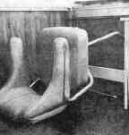
ROAMER MODELS

The major difference between the Roamer and all other models is in the water system for the shower. The Roamer system includes a 12 volt electric water pump and LP gas water heater.

SHOWER SET UP

Lift shower top to upright position and lock in place with barrel lock. Raise shower curtain and track to roof. Secure track to roof with turn fasteners mounted in roof. Remove cap from shower outside drain. Attach drain hose (not supplied with trailer) to drain and insert other end into approved park facilities.

Never drain waste water onto the ground.

ELECTRIC WATER PUMP

The switch, mounted on the cabinet to the right of the shower, turns the pump on and off. The pump operates until the predetermined pressure is reached, then shuts off. As water is turned on, the pump automatically operates to supply water.

CAUTION: Do not operate the pump dry for extended periods.

HOT WATER HEATER LIGHTING INSTRUCTIONS

1. Turn ON main valve at LP gas tank.
2. If gas cock on heater is turned on, turn gas cock to OFF position, wait 5 minutes.
3. Turn to pilot position, press reset button and light pilot. Hold down until pilot remains lit (approx. 60 seconds). Turn to ON position.
4. Set temperature indicator knob to desired temperature.
5. If pilot goes out, repeat steps I, 2, and 3.
- To shut down heater, turn to OFF position.

CAUTION: Do not store combustible materials liquids near or adjacent to this water heater.

ROLL OUT KITCHEN

FOR INSIDE USE....

Raise cabinet by grasping front handles and lifting straight up, until it locks. This must be done as smoothly as possible, lifting both sides evenly.

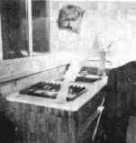
To lower, lift up on rear handles to unlock, Then lower cabinet back down.

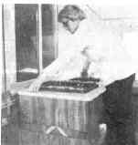
FOR OUTSIDE USE

Unlock and open the outside kitchen access door. Raise the Barrel lock on the right hand side of cabinet and secure it to the up position. Pull out cabinet and lower the barrel latches on both sides of cabinet so that they are against the access door edge. This prevents cabinet from going back in.

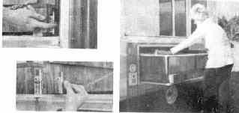

WATER SYSTEM

NOTE: The Roamer model is somewhat different, refer to the special Roamer instructions under the operation section.

SANITIZING THE FRESH WATER SYSTEM

To sanitize the fresh water system, it is recommended that the following procedures be followed for a new system, one that has not been used for a period of time, or one that may have become contaminated.

1. Prepare a solution of one gallon water and 1/4 cup chlorine or household bleach and pour into water storage tank.
2. Complete filling of tank with fresh water. Open faucet until all air has been released from the pipes, and, entire system is filled.
3. Allow to stand for three hours.
4. Drain and flush with fresh water.

To remove any chlorine taste or odor which might remain, prepare a solution of one quart vinegar to five gallons water and allow solution to agitate in tank for several days by vehicle motion. Always drain tank before storing. Pump all water from the line after emptying tank.

WATER STORAGE TANK

The water storage tank on Ramada's is located inside the second storage compartment from the rear of the trailer. On all others, it is located inside the left rear seat box. Open the filler hatch on the left side of the trailer body and fill the tank to capacity, using a garden hose or sanitary container. To drain the tank for travel. Unscrew the cap on the tank drain hose located under the floor.

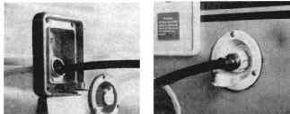

CITY WATER HOOK—UP SYSTEM

To connect your trailer directly to a “city water” supply, unscrew the plug in the “city water connection’ on the left side of the trailer body and connect one end of your hose to the connection. Connect the other end to the water source. Open the valve at the source and you are ready to draw water from the galley faucet. Check the fittings inside the trailer immediately to be sure a non-leaking connection has been made.

WASTE WATER DISPOSAL SYSTEM

All Apache sinks are equipped with a drain hose adapter (the external hose is not supplied) for waste water disposal into approved park facilities. Never drain waste water onto the ground. If a park facility is not available use a bucket or other suitable container. IMPORTANT: After flipping over the sink cabinet into position, open the upper cabinet and work excess drain hose into lower half of cabinet to assure a free flow of water. When folding the sink cabinet for travel, water remaining in the sink trap may flow out. To prevent spillage, fold the cabinet slowly and absorb the water with a cloth or sponge.

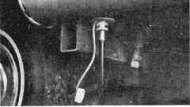
GALLEY FAUCET

When the unit is connected to a source of water pressure, it will respond as an ordinary faucet. Water flow maybe started or stopped simply by opening or closing the faucet knob.

NOTE: If water does not shut off, unscrew small hose adapter on bottom of pump and center small ½” rubber disc. The hand pump may be operated by completely unscrewing the knob (about 4 full turns) and operating it up and down to draw fresh water from the supply tank. It is not necessary to screw the knob back down after each use. The screw in plug in the city water hatch must be tight.

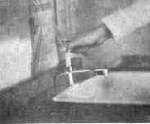

ELECTRICAL SYSTEMS

GENERAL

There are three distinct and separate electrical systems in your vehicle. One is the 110 volt AC system to allow use of appliances such as, toasters, radios, table lamps, etc. Depending on the type of vehicle you own, there may be one or more 110 circuits within the system. The other two systems are 12 volt DC. They consist of the exterior lighting (running, stop, turn, and clearance lights) and appliances.

APPLIANCES

Refer to the appliance heading under operation.

110 VOLT AC SYSTEM

Power is obtained by plugging the 110 V power supply cord of your vehicle into a 110 volt 60 c receptacle. Protection for each circuit is provided for by a circuit breaker. Refer to the 110 V wiring schematic for 110 system layout. If a circuit breaker should kick off, check that the circuit is not overloaded with too many appliances.

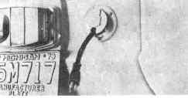
12 VOLT DC EXT. LIGHTING SYSTEM

The exterior lights are connected directly to the tow vehicle lighting. Fuses for these circuits are therefore those in the tow vehicle. Refer to the 12v wiring schematic for typical systems layout.

12 VOLT INTERIOR SYSTEM

All 12 volt lights and the furnace operate through one circuit. Power for operation is derived from the tow vehicle battery, RV battery, or converter, if your RV is so equipped. Trailers with factory installed refrigerators have a separate power line for the refrigerator.

TOW VEHICLE BATTERY

Power from the tow vehicle battery is derived through the accessory terminal in the trailer connector. The corresponding terminal in your tow vehicle connector must be connected directly to the battery. Connection must be made with 12 gauge wire and fused with a 15 amp in line fuse, not further than 12 inches from the battery. 12 volt power is then available from the tow vehicle battery as long as the trailer to vehicle connection is made. If your trailer has a refrigerator, a separate battery connection must be made just like the accessory line.

NOTE: A refrigerator and furnace can rapidly drain a battery when in operation. Therefore, frequently recharge the battery. In weather where temperatures dip below freezing, battery capacity is drastically reduced and charging will be necessary more often.

RV BATTERY (NOT FACTORY INSTALLED OR SUPPLIED)

RV batteries are those batteries mounted on the recreation vehicle to provide power for 12 volt internal lighting and appliance operation. It is a second battery which if drained down in power, does not affect starting of the tow vehicle engine.

NOTE: Should be installed outside the vehicle or in a sealed area vented to the outside if in the RV. A battery protector should be installed in the towing vehicle.

CONVERTER (IF SO EQUIPPED)

When the power cord is plugged into a 110 volt power source, the converter rectifies the 110V AC to 12V DC. This, then will supply power for operation of 12 volt lights and appliances.

A. USING THE CAR’S 12 VOLT BATTERY.
Connect the car to the trailer electrical hook-up and push the converter switch to the battery position. This will provide the necessary current for operation of the 12 volt accessories. Excessive drain on the battery can be prevented by running the engine at fast idle to recharge.
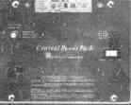
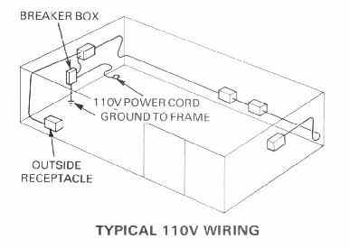
B. USING AN OUTSIDE 110 VOLT POWER SOURCE.
The power cord is pulled out of the outside access hatch and plugged into the 110 volt source. The cord has a three prong, grounding plug. Do not use any adapter which will not continue this ground or inter-change it with a current carrying lead. Push the switch to the trans or converter position. The 110 volt electricity will then be converted to 12 volt DC for operation of the 12 volt accessories. As mentioned earlier, the converter is equipped with circuit breakers for 110 and 12 volt currents. If a breaker trips, the cause should be located and corrected.

CAUTION: DC powered radio or stereo equipment must have an electronic filter installed between the equipment and the converter. Consult your local audio equipment dealer for types of filters and installation,

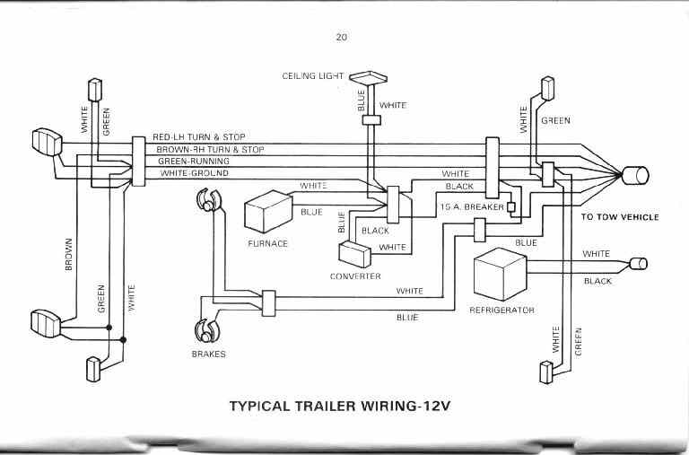
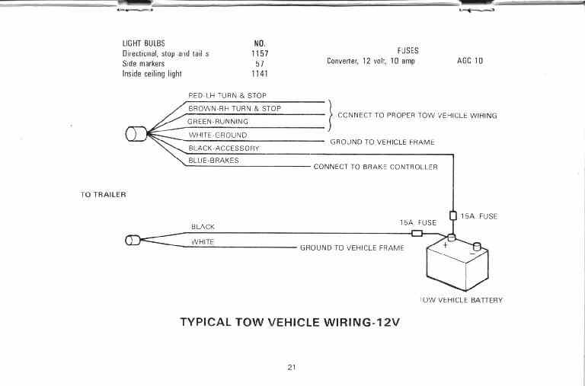

ELECTRIC TROUBLESHOOTING

EXTERIOR LIGHTING SYMPTOM POSSIBLE CAUSES

1. All running lights are out. 1. Poor connection between trailer and tow vehicle.
2. Bad ground in tow vehicle harness connection.
3. Blown fuse in tow vehicle.*

2. One light does not work. 1. Burned out bulb.
2. Bulb loose or missing.
3. Corrosion on bulb base or socket
4. Bad ground in socket.

3. Turn signals do not work. 1. Blown fuse in tow vehicle.*
2. Tow vehicle does not have heavy duty flasher.
3. Tow vehicle wired improperly.

- Lights do not work properly. 1. Wiring of trailer and tow vehicle connections are not
(for example: turn signal flashes all lights). the same.
2. Bad ground in tow vehicle harness connection.

INTERIOR (12V) SYMPTOM POSSIBLE CAUSES

- All interior connections dead when connected to tow 1. Converter must be switched to convert position.
vehicle. 2. Blown fuse in converter.*
3. Breaker in front panel of trailer faulty.
4. Poor connection between trailer and tow vehicle.

- All interior connections dead when 110V. power cord 1. Converter must be switched to convert position.
is plugged in. 2. Blown fuse in converter.*
3. Breaker in front panel of trailer faulty.
4. Main circuit breaker is not switched on.*
5. No power at campsite plug that power cord is
plugged into.

3. Ceiling light does not work 1. Side wall harness not plugged in.
2. Bulb burned out or loose.

110 VOLT SYMPTOM POSSIBLE CAUSES

1. No power. 1. Main circuit breaker is not switched on.*
2. No power at campsite plug that power cord is
plugged into.

* If fuse blows again, or breaker trips off again, check for possible causes (overload or short).

LP GAS SYSTEM

The gas system in your recreation vehicle consists of the tank, two-stage regulator, gas operated appliances, and the lines connecting them. It is installed in accordance with standards for Liquefied petroleum (LP gas) only. LP gas (propane, butane) is stored as a liquid, and vaporized to a gas, which becomes combustible when combined with air.

THE GAS TANK OR BOTTLE

The gas tank serves as the storage container and the vaporization chamber. A properly filled tank is only 80% full of liquid with 20% left for the vaporization to occur. Tanks are designed for definite mounting positions (horizontal, vertical). When equipped with double bottles, open and use one bottle at a time. The main valve is opened and closed with the large knob, allowing the gas to leave the bottle. The safety relief valve automatically opens and closes to allow excess pressure to be relieved from the bottle. The liquid level ensures that the proper vapor space exists in the bottle. In reality, it is a liquid level indicator.

When you have your bottle filled, open the liquid level valve. This should be done in an open area, away from any flame. You will hear a loud hissing from the gas escaping. If you see a white-frosty vapor coming out, the bottle is over-filled. Allow this to discharge until invisible and close the valve. The bottle is now properly filled. Keep hands away from vapor.

CAUTION: AN OVER-FILLED GAS BOTTLE CAN BE DANGEROUS
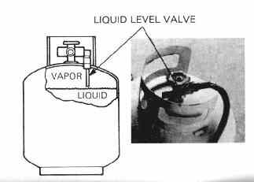
During the manufacture of gas bottles, they are often subjected to a pressure test with water. Seldom is all of it removed. This water can ice up the regulator orifice, reducing the volume of gas. In addition to being annoying, this condition can be hazardous. Therefore, before the first initial filling, add 1/2 cup of methanol alcohol to each bottle. This is done by pouring it into the main valve, when the bottle is empty. Always keep bottle closed when not in use to prevent any future moisture from collecting inside. On trailers with removable bottles, use care in disconnecting them for filling. The line connection to them is a machined male brass fitting with left hand threads. It seats securely to the female seat of the bottle valve and does not require pipe dope.

THE REGULATOR

The regulator reduces and controls the gas pressure allowed into the system from the gas bottles. This is preset for 11” of water column (6 ounces per square inch) and must not be tampered with.

THE APPLIANCES

With properly filled gas bottle installed, make sure all gas appliances are turned off. Then, turn gas on at bottle. Initially after refilling an empty tank, there will be a delay in lighting any appliance. This is due to air in the lines. See the operation section of this manual for appliance operation.

LINES AND FITTINGS

Road vibration can loosen fittings. Therefore, frequently check lines and fittings. Look for sharp bends or breaks in the tubing. Check for leaks using a soap (ivory bar) and water solution. Bubbles at the fitting will indicate a leak. NEVER USE MATCHES. If you think LP gas has leaked into your camper:

1. Do not strike a match.
2. Get all persons out.
3. Turn off gas bottle/bottles.
4. Leave door open and allow trailer to air out.
5. Find and correct leak before using the gas system again.

SAFETY PRECAUTIONS

1. Never allow your tank to be filled above the designed liquid level.
2. Check lines and fittings periodically.
3. Keep tank in proper mounted position so that you only withdraw the vapor. Also make sure it is securely fastened.

HOW LONG WILL YOUR FULL TANK LAST?

Each gallon of liquid LP gas contains approximately 92,000 BTU’s of heat energy; or, putting it another way, each gallon of LP gas produces approximately 36 cubic feet of vapor gas for cooking, heating, water heating and refrigerating. The difference between Butane and Propane is simply-Butane boils (makes vapor gas) at temperatures above 24⁰ F, Propane boils (makes vapor gas) at temperatures above 44⁰ F. below zero. Therefore, propane is recommended for cold climate areas.

To find out how long a gallon of LP gas will last, you should find out what the total BTU/Hr. in-put is on all your LP gas appliances. Let’s say you have a heater that has a 10,000 BTU in-put per hour of operation, a gallon of LP gas would last 9.2 hours of continuous operation, (92.000/10,000 = 9.2). That’s how long a gallon of LP gas will last, what about your full tank? Try to determine what your total daily BTU in-put is. Multiply the estimated hours of each appliances’s use times its rated BTU/Hr. in-put. (The appliance BTU/Hr in-put is marked on its data plate). Add up all the appliance BTU’s/Hr. for your daily total. Then divide your daily BTU/Hr. in-put into your full bottle BTU’s. The result is the number of days the bottle will last.

EXAMPLE:
ESTIMATED
HOURS OF DAILY
BTU/HR x USE IN ONE = APPLIANCE
IN-PUT DAY BTU IN-PUT
Its cold at night, so
our furnace will use 16,000 x 8 = 128,000
We’ll cook on 2
burners (each burner
is 5200 BTUs) 10,400 x 2 = 20,800

TOTAL DAILY BTU IN-PUT 148,800

Our 20 lb. bottle is full so it has a capacity of 460,000 BTU / 148,800, our estimated daily BTIJ in-put = 3 days the bottle will last.

GAS BOTTLES AND BTU CAPACITY (PROPANE)

Bottle or Approx. gallons 92,000 Total BTUs
tank size of liquid LP gas x BTU’s = of full bottle

20lb. 5 x 92,000 = 460,000
30Ib. 7 x 92,000 = 644,000
401b. 9.4 x 92,000 = 864,000

HOW TO KEEP YOUR APACHE LOOKING NEW

PAINTED ALUMINUM BODY PANELS
Wash frequently to preserve the original beauty and prevent damage from road dirt, tree sap and other substances. Flush thoroughly with cool water to remove surface dirt. Then, wash with a sponge or soft cloth and any mild household soap or liquid car-wash preparation. Rinse with cool water and wipe dry with a clean soft towel or chamois. Never wipe dust from dry painted surfaces or scratches will result. Never wash with hot water or when painted surfaces are hot.

Grease, tar, sap or other stubborn stains that remain after washing should be removed with a solvent recommended for cleaning this type of soil from automotive finishes. Never allow sap or resin to remain on surfaces or sunlight and time will harden these substances and make them difficult to remove without damaging the paint.

To help keep painted surfaces clean and protected from harmful deposits, polish with any non-abrasive, liquid or paste automotive wax.

NON ANODIZED ALUMINUM EXTRUSIONS
They can be brought to a high luster by cleaning them with products such as BRASSO or BOYERS METAL CLEANER. Use a soft cloth to apply these cleaners. Polish to a high gloss with a dry soft cloth.

ABS THERMOPLASTIC SURFACES (trailer roof and sidewalls)
Wash with warm water, soap and a soft bristle brush. Tree sap and other stains can be removed with a denatured alcohol or liquid house hold cleaner or detergent. Never use cloths containing grit or abrasive particles, or kitchen scouring compounds. Never use boiling water or strong solvents, as these may soften the coating. Surface scratches and abrasions can be removed with light buffing, using a fine rubbing compound. Waxing is recommended for maintaining the original gloss, but only non-cleaning liquid or paste waxes should be used.

REFRIGERATOR OR ICE BOX
The cabinet interior should be cleaned regularly. Remove the shelves and wash the lining with lukewarm water to which a little soap flakes may be added. Dry thoroughly, especially around door frames and door gasket. Warm water only should be used to wash the cooling evaporator, ice trays and shelves. Plastic dishes may be washed in warm soapy water - not hotter than is bearable to the hand. Do not expose them to dry heat. Never use strong chemicals or abrasive cleaning materials on any part of the cabinet.

WINDOWS
Wash with mild soap and water, and a soft cloth or sponge. Never wipe dust off windows with a dry cloth or scratches will result. Do not use household window cleaning preparations, except those specifically recommended for cleaning plastic windows.

VINYL FLOOR COVERING
Clean with a damp sponge or mop and mild soap and water solution. Never use abrasive cleaners or solvents, such as alcohol. An occasional polishing with a liquid wax recommended for vinyl floors will maintain the luster and help protect against scuffing.

UPHOLSTERY
Seat cushions and mattresses should be cleaned with a foam type upholstery cleaner. Avoid over-wetting.

TABLE AND CABINET TOPS
Wipe clean with a damp cloth or use any cleaner or wax recommended for plastic-laminate surfaces. Although the table and cabinet tops in your Apache are heat resistant, avoid placing extremely hot pots or dishes on these surfaces without using a hot-pad or protective cloth.

DRAPERIES
The draperies in your Apache are tailored from high-quality fabric and should be washed in cold water only.

CABINETS
The wood paneling should be cared for much like the paneling you may have in your home.

RANGE
1. Remove grates by lifting spring clips securing them.
2. Remove screw between rear burners and pull off control knobs to remove top. NOTE: at this point top is held by spring catches on either side of range.
3. Burners are removed by taking out the screws securing them and slipping the burner tube off the control valve.
4. Range top and burners are cleaned with warm water and soap. Oven cleaners or scouring pads should not be used.
5. When installing burners, make sure they are completely dried or rust will form.

MAINTENANCE

GENERAL BODY
A. A silicone spray type lubricant should be used for lubricating the bed sliders and main sidewall rollers.
B. Leveling legs should be kept clean and lubricated to ensure ease of operation.
C. Periodically check tightness of screws.
D. Periodically check tightness of bed leg holder screws, located on the leveling leg mounting plate. These screws have been adjusted by your dealer to raise or lower the outer bed end. This adjustment ensures the proper bed roof and rear wall angle to match the sliding bed sidewall.
E. The bed sliding wall cloth hinges can be periodically lubricated by rubbing with paraffin wax.

HITCH
Apply a light coating of petroleum jelly to the ball to prevent corrosion. It is recommended that a Class II, weight-carrying frame hitch be used. Do not use a weight-distributing (equalizer-type hitch), as it may cause damage to the trailer.

TONGUE JACK
Check mounting bolts occasionally and re-tighten as necessary. Oil the mechanism with a light bodied oil.

LIFT SYSTEM
The lift system requires annual lubrication of the lift chains and track. Lubrication should be more often if trailer is used often in dusty or sandy climates. See your Apache dealer for annual lubrication service.

ELECTRIC BRAKE ADJUSTMENT
Fayette Electric Brakes, regardless of size, are of two-shoe variety and adjust as most other automatic brakes do. They have a brake adjusting screw at the bottom, which is covered by a plug accessible through the backing plate. Use a standard brake adjusting tool or screwdriver to turn screw until the brake lining contacts the drum with sufficient force to make the wheel difficult to turn by hand. Back off the screw 6 to 8 clicks, or until the wheel spins with some noticeable drag of the linings on the drum brake band. A brake improperly adjusted (too loose) not only loses its effectiveness, but may also tend to “dunk’ or grab at slow speeds.

WHEEL BEARINGS
Bearings will run the coolest and with the least friction when a minimum amount of the lightest bodied lubricant that will keep bearing surfaces apart is used. Heat in bearings is due to a number of causes such as (a) too much lubricant. (b) too heavy lubricant, (c) too tight adjustment. We know that our bearings have to function under high temperatures due to the electric brake heat, so we have chosen lubricants of such a character that they will return to their original consistency when the bearing cools, with practically no oil separation. We use and recommend Sunoco 802 or Sunoco Prestige 742EP. Fayette recommends that wheel bearings be inspected and repacked every 20,000 miles or at the start of every vacation season. A trailer sitting idle for a few months will collect some moisture in the hubs due to the atmospheric conditions and this is the reason for inspecting and repacking bearings at this time

GAS SYSTEM
Periodic checks of the gas system for leaks is all that is necessary. Visually inspect lines, especially those under the floor, for physical damage. If an appliance such as; the furnace seems not to be getting gas, check the burner. Spiders have an attraction to building webs in burner orifices thereby plugging gas flow.

FURNACE
The furnace should be inspected and thoroughly cleaned by a qualified service agency before each heating season. This would include the combustion chamber, the main burner, the blower assembly, and all control parts. A careful inspection of all gaskets should be made and if any gaskets show signs of leakage or deterioration, they should be replace. Cleaning of the chamber and main burner will be required if the unit has been allowed to operate with a high yellow flame. The yellow flame is due to incomplete combustion (lack of air) and will deposit a soot formation inside the chamber and on the main burner. To clean the chamber, main burner, blower assembly and controls, the chamber assembly must be pulled from the furnace cabinet. The furnace is equipped with an oiled, sealed motor and requires no oiling.

TIRES
For longer tire life and better trailer towing performance, recommended tire pressure should be maintained at all times. Check inflation pressure regularly. This should be done when trailer has been standing for at least three hours or towed less than one mile. An increase in pressure is normal when traveling. Never let air out of the tires to compensate for this increase. The tires on your Apache are covered by the tire manufacturer’s warranty.

RECOMMENDED COLDTIRE INFLATION PRESSURES
20.5 x 8.0-10” @ 50 PSI.
5.30 x 12” @ 80 PSI

STORAGE

1. Clean entire unit.
2. Block trailer up to relieve weight from tires.
3. Remove gas bottle and make sure it’s closed.
4. Drain all water out of water system. NOTE: On Roamer model it will be difficult to remove all water from the system, water pump, and heater without blowing the lines out with air. An alternative is to fill the system with a non-toxic anti-freeze intended for this purpose.
5. Plug gas line to prevent dirt or insects from entering.
6. Crank tongue jack up so that front is higher than rear, if trailer is not stored in garage or shelter. Ice or snow should not be allowed to accumulate on the road cover.
7. Check that all access hatches are closed.
8. If stored outside, remove cushions, mattresses and curtains.
9. Periodically open and air the unit on a warm day.
10. Do not store your trailer under trees, if at all possible.
11. Do not cover top with a canvas tarp or similar material in warm weather. The heat build-up will cause permanent deformation of the road cover.
12. During winter months brush excessive snow from roof.

SPRING CHECK-UP

1. Remove trailer from storage, open, and air out.
2. Re-pack wheel bearings.
3. Check condition of electrical hook-up on trailer and car.
4. Check condition of gas bottles, clean, and apply coat of good reflective paint.
5. Check water and gas system for leaks.
6. Check for loose bolts, or screws.
7. Check electrical system operation.

SPECIFICATIONS

CLOSED GROSS
LENGTH VEHICLE MAXIMUM GROSS
CLOSED REAR TO SHIPPING WEIGHT CARRYING TONGUE
ROAD WIDTH CENTER WEIGHT RATING CAPACITY WEIGHT
MODEL NAME HEIGHT (OUTSIDE) OF BALL TIRES (LBS) (LBS) (LBS) (LBS)
Ramada 4’6” 6’7-7/8” 16’6 1/2” 20.5x8x10 1950# 2400# 4504 240-288
Cimarron 4’6’ 6’7-7/8” 16’6 1/2” 20.5x8x10 1930# 2400$ 4704 240-288
Roamer 4’6” 6’7-7/8” 16’6W’ 20.5x8x10 1950# 2400# 4504 240-288
Ranger 4’6” 6’7-7/8” 14’l0 1/2” 20,5x8x10 1760# 2400$ 6404 240-288
Royal 4’8” 6’7-7/8” 14’10 1/2” 5.30x12 1650# 2280# 5304 228-474
Mesa 4’8” 6’7-7/8” 13’ 1/2” 5.30x12 1480# 1990# 5104 199-239
Yuma I 4’8” 6’7-7/8” 13’ 1/2” 5.30x12 1500# 1990# 4904 199-239

The maximum carrying capacity is the difference between the shipping weight (standard equipment with all systems dry), and the gross vehicle weight. On a Ranger for example: Gross vehicle weight rating (2400#)—shipping weight 1760#)= Maximum carrying capacity (640#).

From this capacity you must subtract:
A. Optional equipment you may have:
(1) Refrigerator (50#)
(2) Furnace (27#)
(3) Second gas bottle, dry (26#)
(4) Spare tire (26#)
(5) Other equipment (canopy, toilet, privacy curtains, etc.)
B. Liquids for systems:
(1) LP gas (20#, each bottle)
(2) Water (Approx. 80#, full tank)
The balance is the available capacity for all other gear, food stuffs, etc.

The gross tongue weight is 10 to 12% of the gross vehicle weight. Therefore, the ranges given are for a fully loaded trailer. If your fully loaded trailer weighs less, the range of the tongue weight also would be less. If your Ranger. fully loaded, weighs 2100 lbs., the tongue weight should be 10 to 12% of 2100 lbs., or 210 to 252 lbs.

